Dear Libyana Team,
Greetings,
Please find attached the Network Performance Report,
which includes 2G, 3G, 4G, VoLTE, and overall traffic metrics

LTE KPIs are working in normal trend and above threshold.
UMTS KPIs are all in normal trend and above the threshold
GSM KPIs analysis KPIs are all in normal trend and above the threshold except for CSSR due to TRX availability
Date | Region | wireless On Air Sites | 2G | 3G | 4G
17-June-2026 | Libyana EAST Network | 795 | 785 | 781 | 670

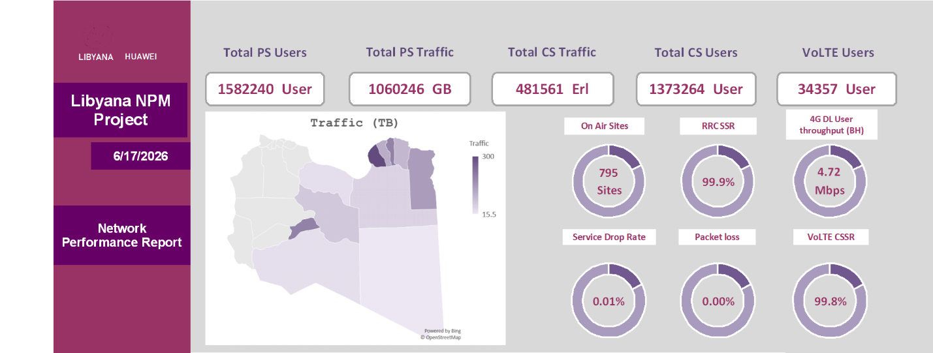

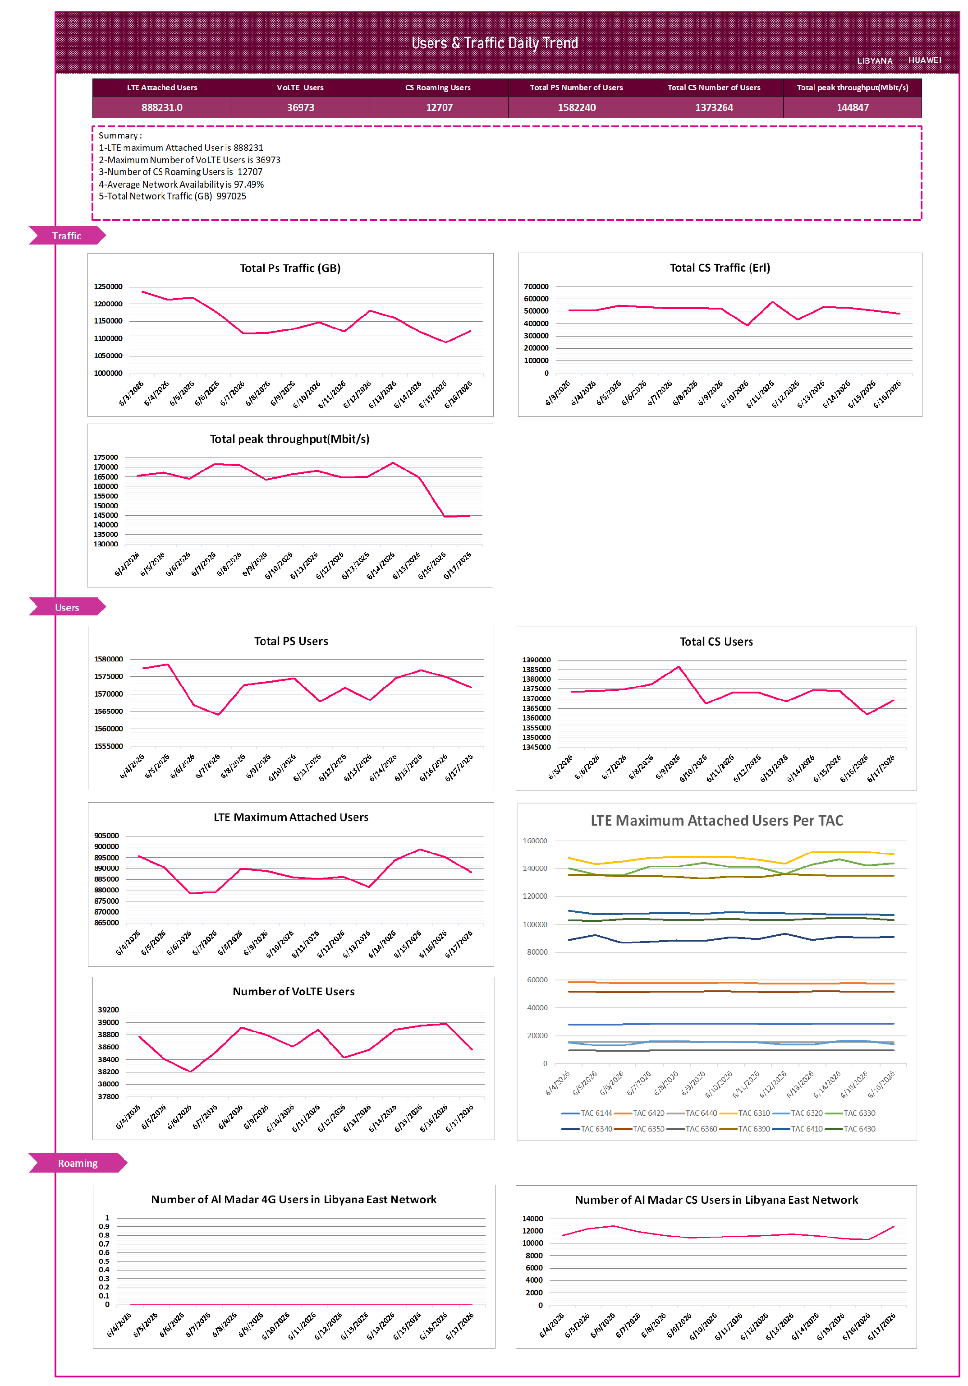

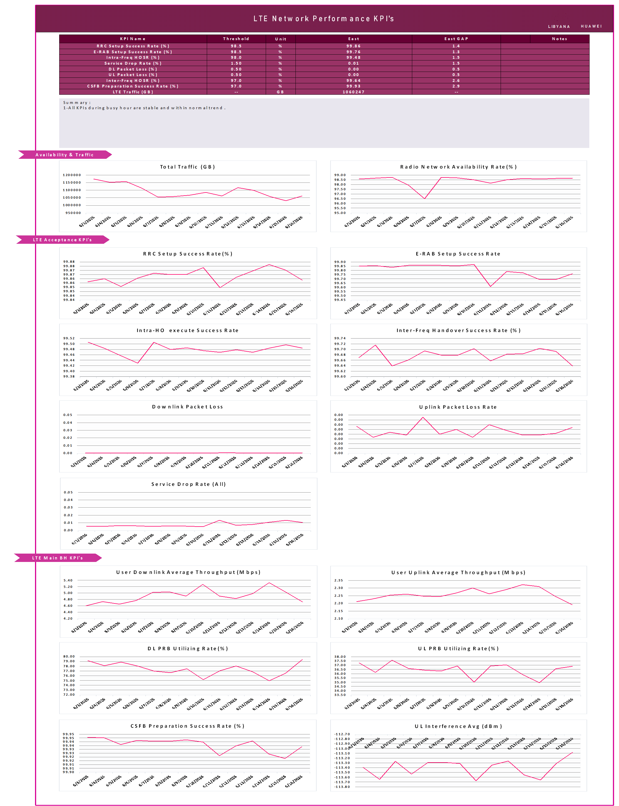

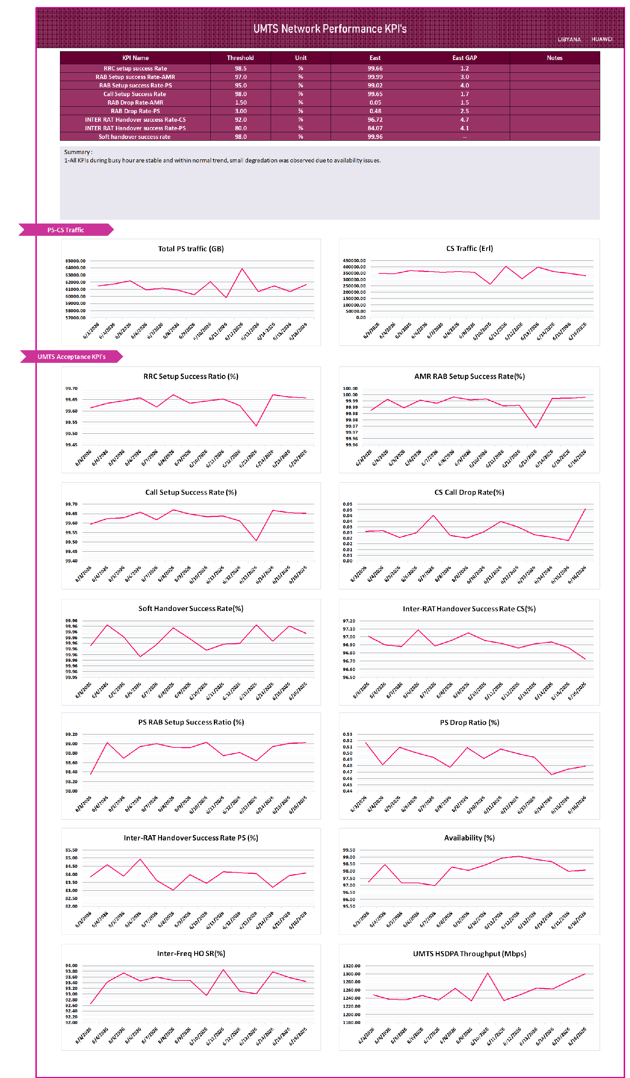

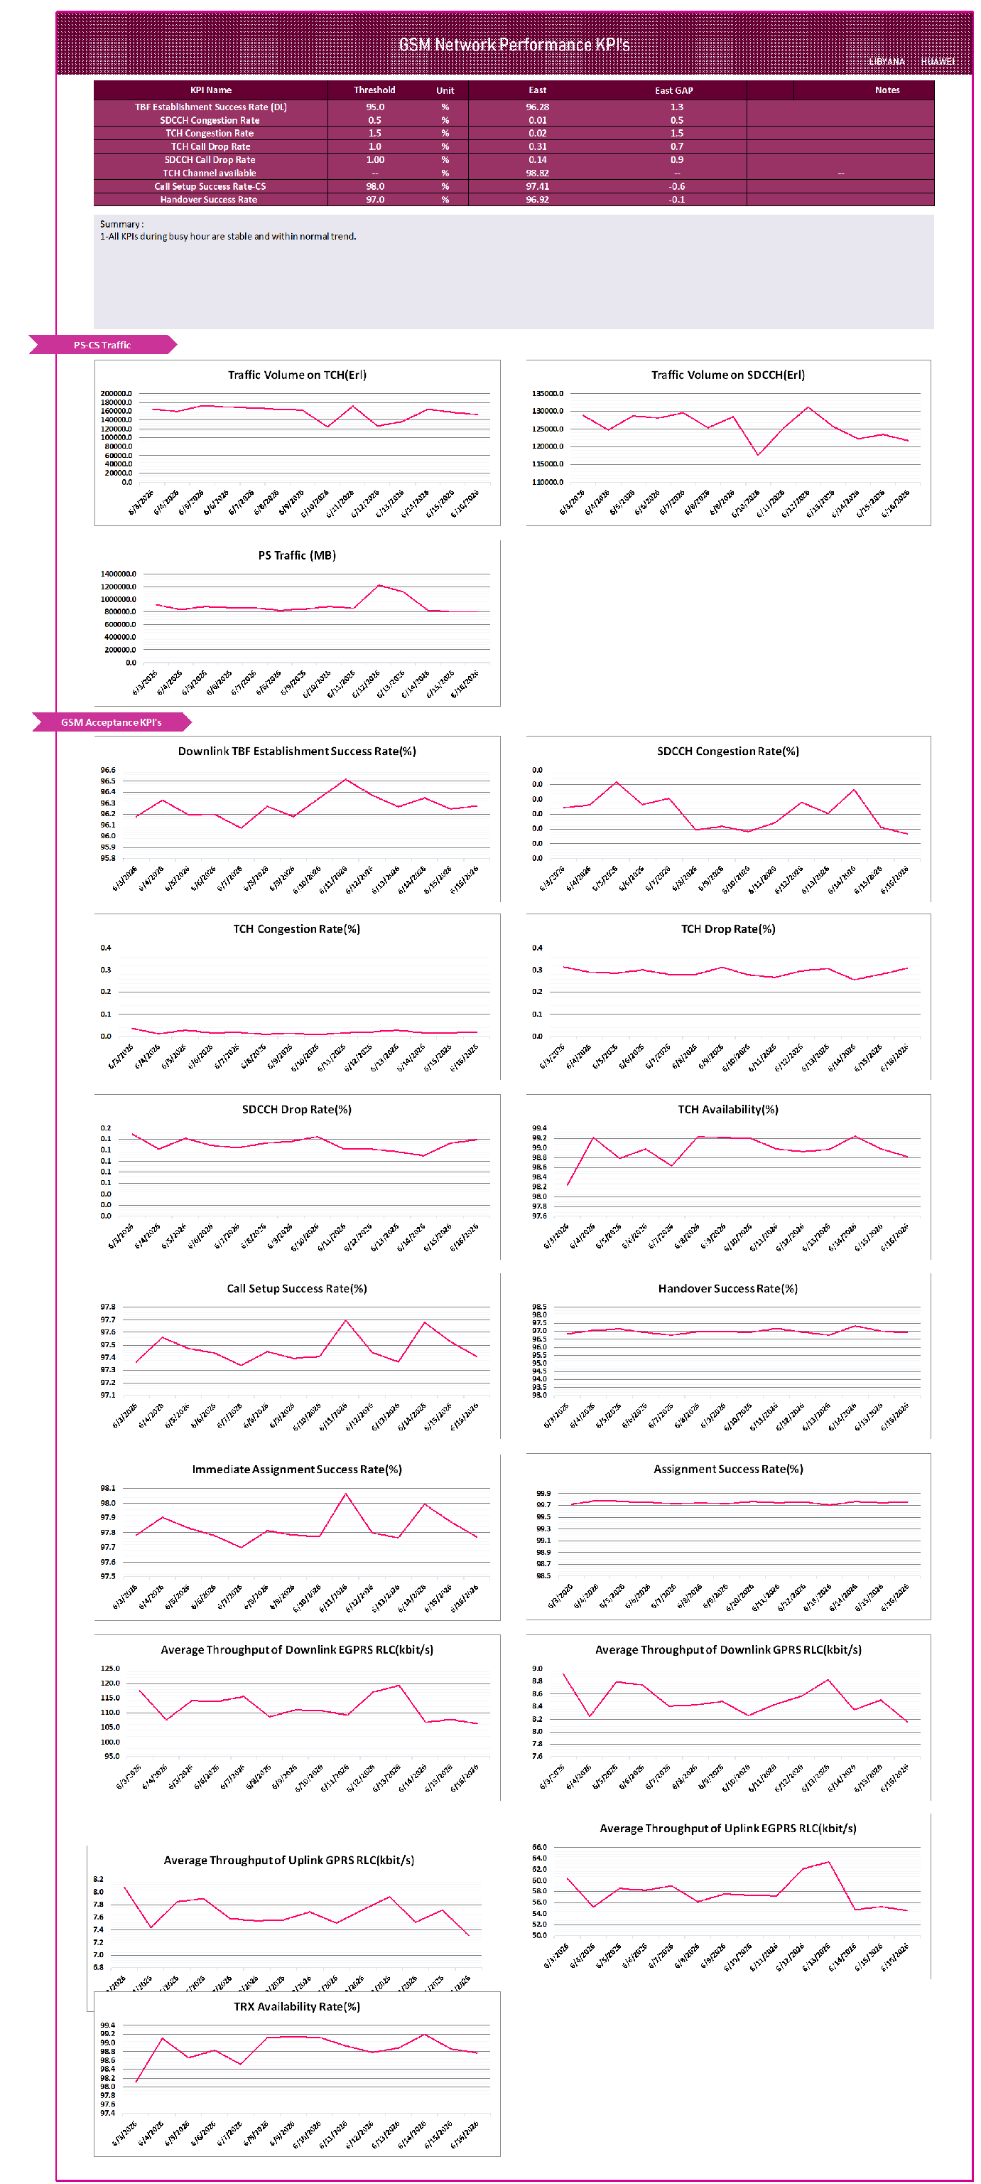

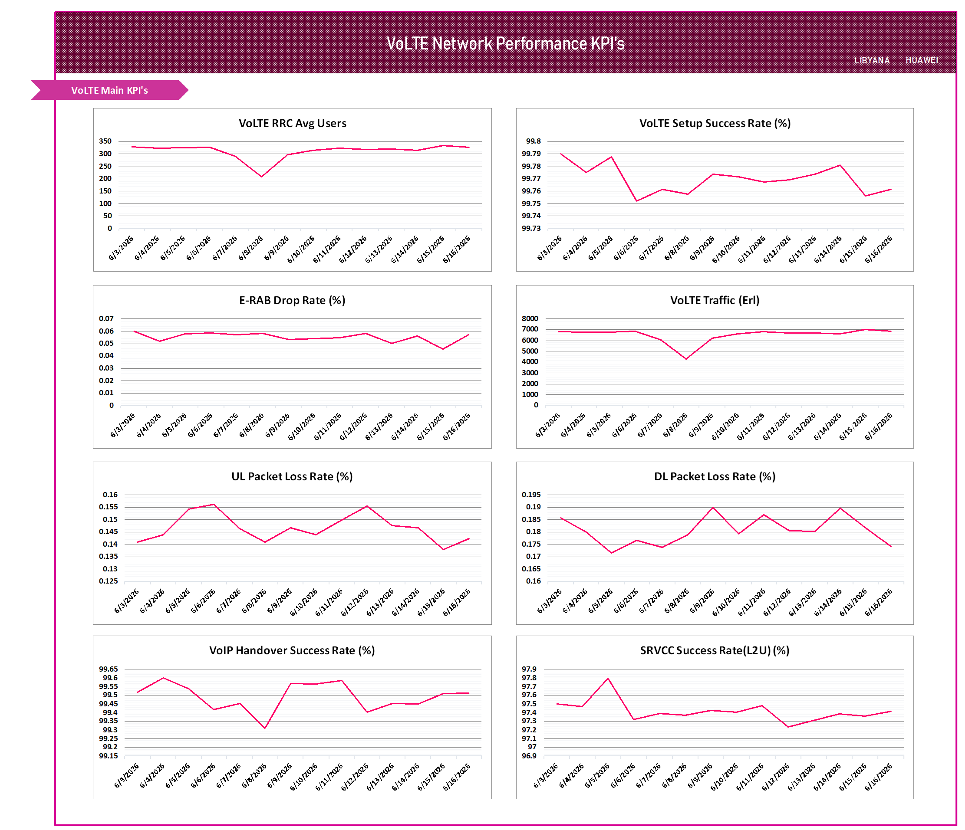

Thanks & BR,

